JSSUNIVERSITY,NOIDA

DEPARMENT OF INFORMATION TECHNOLOGY


JCS408
WebDesigningLab

Submittedto: SubmittedBy:
Mr. KN Chandu Isha Gupta
J240213055
4th Semester
B.TechIT

Index
SNo. | ExperimentParticulars | Experiment Date | SubmissionDate | Signature

Lab1
Experiment1:SetupaGitHubrepositoryforaproject,createbranches,mergechanges,and use GitHub Pages for hosting a simple static site.

CreatingaccountonGitHub:
- Openyourbrowserandgotohttps://github.com
- ClickonSign Up.
- EnteryouremailaddressandclickContinue.
- Createastrongpassword.
- Chooseauniqueusername.
- Verifyyouraccount(email/OTP verification).
- CompletethesetupandlogintoyourGitHubaccount.
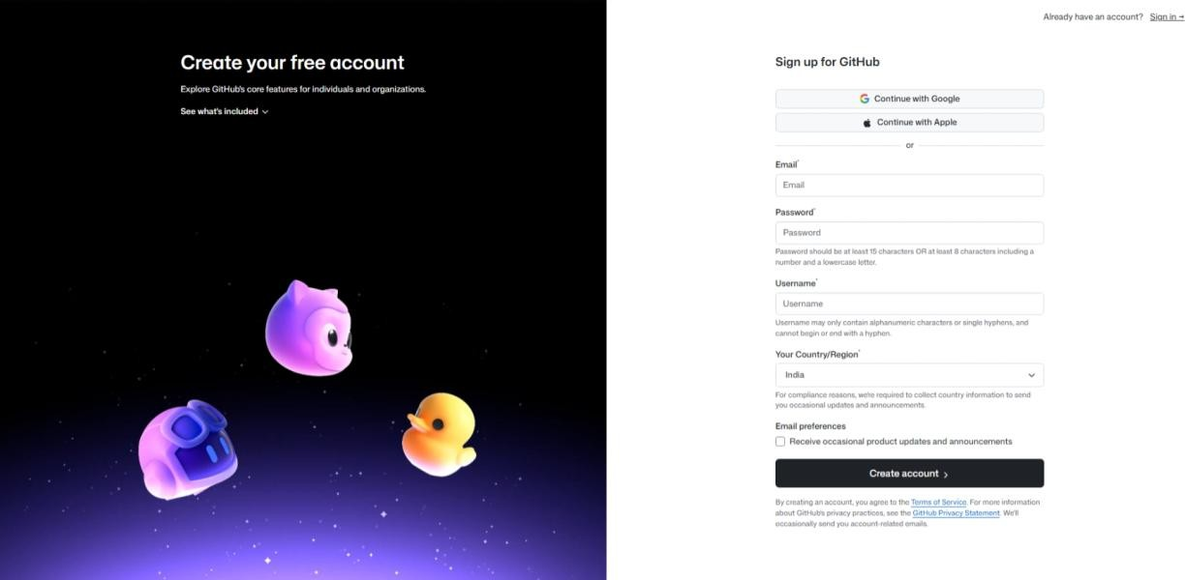

StepstoCreateaNewRepository
- Afterloggingin,clickonthe"+"(plusicon)inthetoprightcorner.
- SelectNewrepository.
- EnteraRepositoryName(e.g.,portfolio-website).
- AddashortDescription(optional).
- Chooserepositoryvisibility:
  - Public(visibletoeveryone)

  - Private(restrictedaccess)
- SelectAddaREADMEfile(recommended).
- ClickCreateRepository.
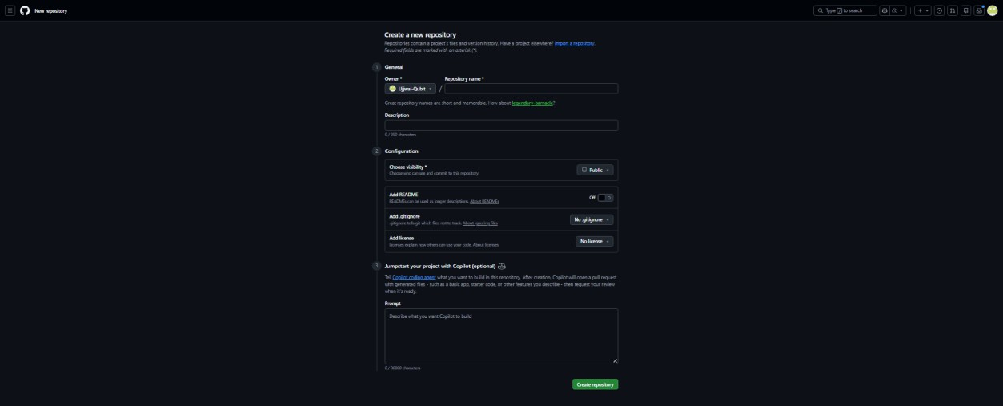

StepstoCreateaBranch
  - Openyourrepository.
  - ClickontheBranchdropdown(usuallyshows“main”).
  - Typeanewbranchname(e.g.,feature-update).
  - ClickCreatebranch.
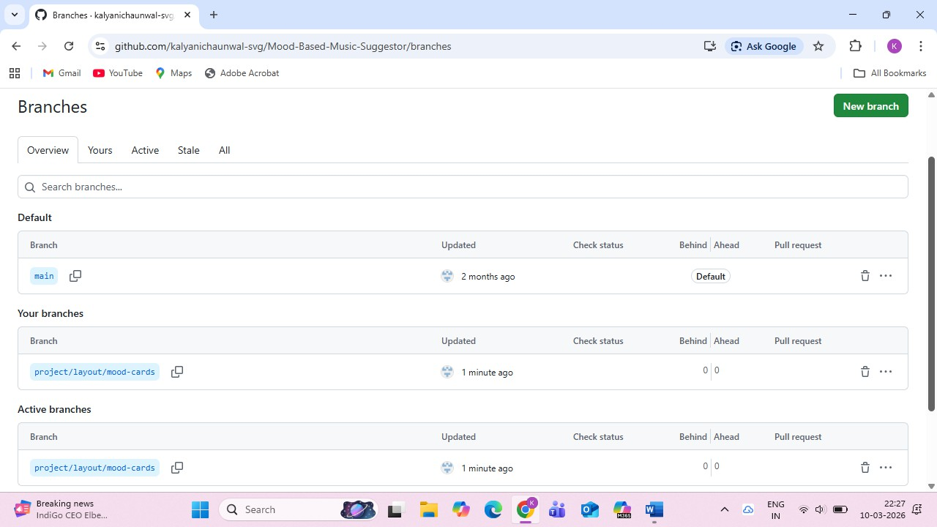

StepstoMakeChangesinaBranch
  - Switchtothenewlycreatedbranch.
  - Editoruploadfiles.
  - Addacommitmessagedescribingthechanges.
  - ClickCommitchanges.
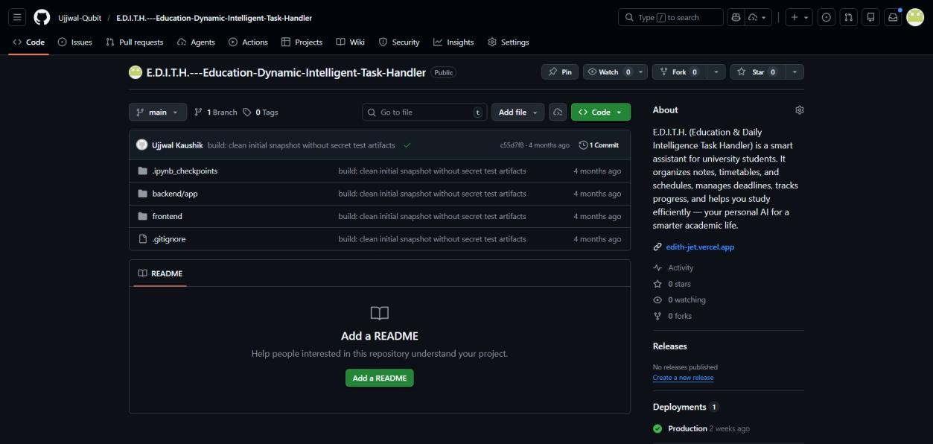

StepstoMergeBranchintoMain
  - Gototherepositoryhomepage.
  - ClickonCompare&PullRequest.
  - Addadescriptionofchanges.
  - ClickCreatePullRequest.
  - ClickMergePullRequest.
  - Confirmmerge.

StepstoHostaStaticWebsiteusingGitHubPages
- Openyourrepository.
- GotoSettingstab.
- ScrolltoPages(underCodeandAutomationsection).
- UnderSource,select:
  - Branch: main

  - Folder: /root
- ClickSave.
- GitHub will generate a live website link like: https://username.github.io/repository-name/
- Openthelinkinyourbrowsertoviewyourhostedwebsite.
Lab2
Experiment2:DevelopapersonalportfoliowebpageusingHTMLandCSS,includinga navigation menu, an about section, a projects section, and a contact form.

Index.html
<!DOCTYPEhtml>
<html lang="en">
<head>
<metacharset="UTF-8"/>
<meta name="viewport" content="width=device-width,initial- scale=1.0" />
<title>MyPortfolio</title>
<linkrel="stylesheet"href="style.css"/>
</head>
<body>
<!--NavigationMenu-->
<header>
<navclass="nav"aria-label="Primary">
<divclass="containernav-row">
<aclass="brand"href="#hero">Isha Gupta</a>
<ulclass="nav-links">
<li><ahref="#hero">Home</a></li>
<li><ahref="#about">About</a></li>
<li><ahref="#projects">Projects</a></li>
<li><ahref="#contact">Contact</a></li>
</ul>
</div>
</nav>
</header>
<!--HeroSection-->
<sectionid="hero" class="section">
<divclass="container hero">
<divclass="hero-text">
<h1><spanclass="text-gradient">Hi,I'm Isha</span></h1>
<pclass="lead">MotivatedB.Tech(IT) 2nd-year student & Software Engineer Intern.</p>
<pclass="sublead">MERN·OpenCV· C++ · Python</p>
<div class="badges">
<span class="badge">MERN</span>
<span class="badge">OpenCV</span>
<span class="badge">C++</span>
<span class="badge">Python</span>
</div>
<ahref="#projects"class="btn">ViewMy Work</a>
</div>
</div>
</section>
<!--AboutSection-->
<sectionid="about" class="section">
<div class="container">
<h2>About Me</h2>
<p>

I am a motivated B.Tech(IT)2nd-year student at JSS University, Noida (GPA: 8.92/10). I interned as a
SoftwareEngineeratDXPSoftwareinHo ChiMinhCity(06/2025-07/2025),where I developed a MERN + OpenCV
face recognition application and contributedtomultiplereal-worldprojects. I'm passionate about AI/ML,
blockchain,DSA,andbuildingpractical software solutions.
</p>
</div>
</section>
<!--ProjectsSection-->
<sectionid="projects"class="section">
<div class="container">
<h2>My Projects</h2>
<div class="projects">
<div class="card">
<h3>SmartFlow</h3>
<p>Smart Traffic Management System. Qualified for the internal round of Smart India Hackathon 2025; an intelligent solutionfortrafficflowoptimization.</p>
</div>
<div class="card">
<h3>PatientID+</h3>
<p>Smart Face Recognition and Data Management System for Hospitals — a projecttostreamlinepatientidentification and records using face recognition and secure data handling.</p>
</div>
<div class="card">
<h3>NutriMom</h3>
<p>AI-based maternal wellness and daily routine recommendation platform. Built during HackDataHackathonandrankedin the Top 10 out of 255 teams.</p>
</div>
</div>
</div>
</section>
<!--ContactSection-->
<sectionid="contact"class="section">
<div class="container">
<h2>ContactMe</h2>
<p style="color:var(--muted);margin- bottom:12px;">Email: ishagupta672@gmail.com•LinkedIn: linkedin.com/in/guptaisha</p>
<formclass="form"action="#" method="post">
<div class="field">
<label for="name">Name</label>
<input type="text" id="name" name="name"placeholder="Enteryour name" required />
</div>
<div class="field">
<label for="email">Email</label>
<input type="email" id="email" name="email"placeholder="Enteryour email" required />
</div>
<div class="field">

<label for="message">Message</label>
<textareaid="message"name="message" rows="5" placeholder="Write your message..."
required></textarea>
</div>
<buttontype="submit"class="btn">Send Message</button>
</form>
</div>
</section>
<!--Footer-->
<footerclass="footer">
<div class="container">
<p>&copy;2025Isha Gupta.All rights reserved.</p>
</div>
</footer>
</body>
</html>Style.css
* {
box-sizing:border-box;
}
:root{
--bg: #0b0f14;
--surface: #0f1623;
--elev: #121b2b;
--line: #1f2a3c;
--text: #e5e7eb;
--muted: #9aa4b2;
--accent:#22d3ee;
--accent2:#7c3aed;
}
html {
scroll-behavior:smooth;
}
body { margin:0;
background:radial-gradient(1200px600px at 10% -10%, rgba(34, 211, 238, 0.05),
transparent),
radial-gradient(1000px500pxat90% 0,
rgba(124,58,237,0.05),transparent), var(--bg);
color:var(--text);
font-family: ui-sans-serif, system-ui, - apple-system,SegoeUI,Roboto,Arial, Apple Color Emoji,
SegoeUIEmoji; line-height: 1.6;
}
a {
color: inherit;
text-decoration: none;
}
img{
max-width:100%; display: block;
}
.container{

max-width:1100px; margin-inline:auto; padding: 0 20px;
}
.section{ padding:64px0;
}
header { position:sticky; top: 0;
z-index: 50;
background:rgba(11,15,20,0.65); backdrop-filter: blur(8px);
border-bottom:1pxsolidvar(--line);
}
.nav-row { display:flex;
align-items:center;
justify-content:space-between; gap: 16px;
height: 64px;
}

.brand{
font-weight: 800; letter-spacing:0.4px;
font-family: ui-monospace, SFMono- Regular,Menlo,Consolas,monospace;
font-size: 20px;
background:linear-gradient(90deg,var(-- accent), var(--accent2));

-webkit-background-clip:text; background-clip: text;
-webkit-text-fill-color:transparent;
}

.nav-links { display:flex; gap: 22px;
list-style:none; margin: 0;
padding:0;
}

.nav a {
color:var(--muted); font-weight: 600; font-size: 14px; padding: 8px 10px; border-radius: 8px;
transition:color0.2s,background0.2s;
}

.nav a:hover,
.nava:focus-visible{ color: var(--text);
background:rgba(124,58,237, 0.12);

outline:2px solid transparent;
}

.hero{ display:grid;

place-items:startcenter; min-height: 52vh;
text-align: center; position: relative; padding-top:24px;
}

.hero:before{ content: ""; position:absolute;
inset:auto-20%-10%-20%; height: 180px;
background: radial-gradient(closest-side, rgba(34,211,238,0.12),transparent70%);
}

.hero-text {
max-width: 800px;
}

.hero h1 { margin:0014px; font-size: 44px;
line-height: 1.15; letter-spacing:0.3px; color: var(--accent);
text-shadow:0012pxrgba(34,211, 238,
0.15);
}

.hero p {
margin: 0 0 28px; color:var(--muted);

font-size:18px;
}

.text-gradient { color:var(--accent);
text-shadow:0012pxrgba(34,211, 238,
0.15);
}

.lead{
margin: 0 0 6px; color:var(--text); font-weight:700; font-size: 20px;
}

.sublead{ margin:0018px;
color:var(--muted);

}

.badges{ display:flex;
justify-content:center; flex-wrap: wrap;
gap: 8px;
margin:00 24px;
}

.badge{
font-size: 12px; color:var(--accent);

background:rgba(34,211,238,0.08);
border:1pxsolidrgba(34,211,238,0.3); padding: 6px 10px;
border-radius:999px;
}

.btn{
display:inline-flex; align-items:center; gap: 10px;
padding: 14px 20px; border-radius: 12px; background:var(--accent); color: #001018;
border:1pxsolidrgba(34,211,238, 0.5);
font-size: 15px; font-weight:800;
letter-spacing:0.3px;
box-shadow:010px30pxrgba(34, 211,
238,0.15),02px8pxrgba(34,211,238,
0.25);
transform:translateY(0);
transition:transform0.15sease,box- shadow 0.2s ease, filter 0.2s ease;
}

.btn:hover{
transform:translateY(-2px); filter: saturate(1.02);
box-shadow:014px40pxrgba(34, 211,
238,0.22),04px12pxrgba(34,211,238,
0.28);
}

h2 {
margin:00 26px;

font-size: 28px; letter-spacing:0.2px; position: relative;
}

h2:after{ content: ""; display:block; width: 56px;

height: 3px; margin-top:10px;
background:linear-gradient(90deg,var(-- accent), transparent);
}

.projects{ display:grid;
grid-template-columns:repeat(3, minmax(0, 1fr));
gap: 18px;
}

.card{
background:linear-gradient(180deg,var(-- elev), var(--surface));
border:1pxsolidvar(--line); border-radius: 14px; padding: 18px;
box-shadow:01px0 rgba(255,255,255,
0.02)inset,010px20pxrgba(0,0, 0,
0.25);
transition:transform0.15sease,border- color 0.2s ease, box-shadow 0.2s ease;
}

.card:hover{
transform:translateY(-4px);

border-color:rgba(34,211,238,0.35);
box-shadow:016px40px rgba(0,0,0,
0.35),000 3pxrgba(124,58,237, 0.12);
}

.card h3 {
margin:2px08px; font-size: 18px;
}

.card p { margin:0;
color:var(--muted);
}

.form{ display:grid; gap: 16px;
max-width:640px;
}

.field{ display:grid; gap: 8px;
}

label {
font-size: 13px; color:var(--muted);
}

input,

textarea{ font:inherit;
color: var(--text); background: #0c1320; border:1pxsolidvar(--line); border-radius: 12px; padding: 12px 14px;
transition:border-color0.2s,box-shadow 0.2s;
resize: vertical;
}

input::placeholder, textarea::placeholder{ color: #6b7787;
}

input:focus, textarea:focus{
outline:2px solid transparent;
border-color:rgba(34,211,238,0.55);
box-shadow:0004pxrgba(34,211,238,
0.12);
}

.footer{
border-top:1pxsolidvar(--line);
padding: 28px 0; color:var(--muted); font-size: 14px; text-align: center;
}

@media(max-width:900px) {
.projects{
grid-template-columns:repeat(2, minmax(0, 1fr));
}
}

@media(max-width:640px) {
.nav-links{ gap: 12px;
}
.section{ padding:48px0;
}
.hero h1 {
font-size:30px;
}
.hero p {
font-size:15px;
}
.projects{
grid-template-columns:1fr;
}}

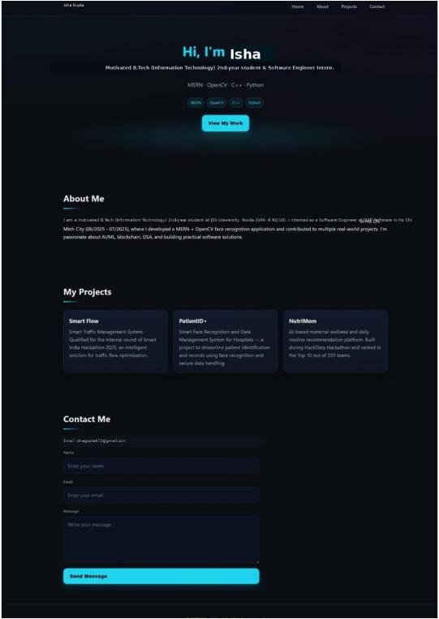

Experiment 3: To study and implement basic HTML tags for creating a simple web page structure.

Introduction
HTML (HyperText Markup Language) is used to design web pages. It uses tags to structure content like text, images, and links.

Basic HTML Structure
<!DOCTYPE html>
<html>
<head>
<title>My First Page</title>
</head>
<body>
<h1>Hello World</h1>
<p>This is my first web page.</p>
</body>
</html>

Basic HTML Tags with Syntax & Use Case
1. Heading Tags
Syntax:
<h1>Heading</h1>
Use: Defines headings (h1 to h6, largest to smallest)

2. Paragraph Tag
Syntax:
<p>This is a paragraph</p>
Use: Adds text content in paragraph form

3. Line Break Tag
Syntax:
<br>
Use: Breaks line without starting new paragraph

4. Anchor Tag (Link)
Syntax:
<a href="https://example.com">Visit Site</a>
Use: Creates hyperlinks

5. Image Tag
Syntax:
<imgsrc="image.jpg" alt="Image">
Use: Displays images on webpage

6. List Tags
Unordered List:
<ul>
<li>Item 1</li>
<li>Item 2</li>
</ul>
Ordered List:
<ol>
<li>Item 1</li>
<li>Item 2</li>
</ol>
Use: Displays lists (bulleted or numbered)

7. Table Tag
Syntax:
<table border="1">
<tr>
<th>Name</th>
<th>Age</th>
</tr>
<tr>
<td>Bunny</td>
<td>20</td>
</tr>
</table>
Use: Creates tables

8. Form Tag
Syntax:
<form>
Name: <input type="text"><br>
<input type="submit">
</form>
Use: Takes user input

9. Bold & Italic
<b>Bold Text</b>
<i>Italic Text</i>
Use: Text formatting

10. Div Tag
<div>
Content here
</div>
Use: Groups elements for styling/layout

Conclusion
Basic HTML tags help in structuring web pages effectively. Understanding these tags is essential for web development.
Experiment 5:Create a weather app using Fetch API or Axios that fetches real-time weather data based on user input.

index.html

<!DOCTYPE html>
<html lang="en">
<head>
<meta charset="UTF-8">
<title>Weather App</title>
<link rel="stylesheet" href="https://unpkg.com/leaflet/dist/leaflet.css" />
<script src="https://unpkg.com/leaflet/dist/leaflet.js"></script>
<style>
body{
font-family: Arial, sans-serif;
background: linear-gradient(135deg,#4facfe,#00f2fe);
display:flex;
height:100vh;
margin:0;
}

.map-container{
flex:1;
height:100%;
}

.container{
background:white;
padding:30px;
border-radius:15px;
text-align:center;
width:350px;
box-shadow:0 10px 25px rgba(0,0,0,0.2);
}

h1{
margin-bottom:20px;
}

input{
padding:10px;
width:70%;
border-radius:8px;
border:1px solid #ccc;
}

button{
padding:10px 15px;
border:none;
background:#4facfe;
color:white;
border-radius:8px;
cursor:pointer;
}

button:hover{
background:#2196f3;
}

.weather-icon{
width:80px;
}

#result{
margin-top:20px;
}
</style>

</head>
<body>

<div class="map-container" id="map"></div>

<div class="container">
<h1>🌤 Weather App</h1>
<input type="text" id="city" placeholder="Enter city">
<button onclick="getWeather()">Search</button>
<div id="result"></div>
</div>

<script>

let map = L.map('map').setView([20, 0], 2);

L.tileLayer('https://{s}.tile.openstreetmap.org/{z}/{x}/{y}.png', {
attribution: '&copy; OpenStreetMap contributors'
}).addTo(map);

let marker;

async function getWeather(){
const city = document.getElementById("city").value;
constapiKey = "8d159f3058df8a56f0337338593dd395";

if(city===""){
document.getElementById("result").innerHTML="Enter a city name";
return;
}

const url=`https://api.openweathermap.org/data/2.5/weather?q=${city}&appid=${apiKey}&units=metric`;

try{
const response = await fetch(url);
const data = await response.json();
if(data.cod!=200){
throw new Error(data.message);
}

const icon = data.weather[0].icon;

document.getElementById("result").innerHTML = `
<h2>${data.name}, ${data.sys.country}</h2>
<img class="weather-icon" src="https://openweathermap.org/img/wn/${icon}@2x.png">
<p><b>${data.main.temp} °C</b></p>
<p>${data.weather[0].description}</p>
<p>Humidity: ${data.main.humidity}%</p>
<p>Wind: ${data.wind.speed} m/s</p>
`;

const lat = data.coord.lat;
const lon = data.coord.lon;
map.setView([lat, lon], 10);

if(marker){
marker.setLatLng([lat, lon]);
} else {
marker = L.marker([lat, lon]).addTo(map);
}

} catch(error){
document.getElementById("result").innerHTML= `<p style="color:red">${error.message}</p>`;
}
}
</script>
</body>
</html>

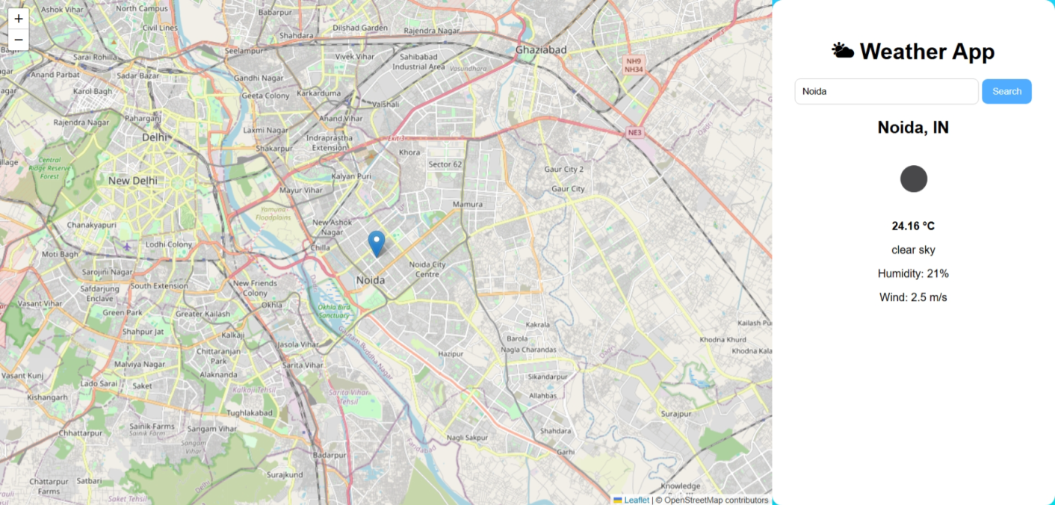

Experiment 4

Aim:Optimize a given webpage for SEO and accessibility by implementing semantic HTML, proper heading structure, and meta tags.

Search Engine Optimization (SEO) helps improve the visibility of a website on search engines. Accessibility ensures that web content is usable by everyone, including people with disabilities. Using semantic HTML, proper heading structure, and meta tags improves both SEO and accessibility.

Optimized HTML Structure
<!DOCTYPE html>
<html lang="en">
<head>
<meta charset="UTF-8">
<meta name="viewport" content="width=device-width, initial-scale=1.0">
<!-- SEO Meta Tags -->
<meta name="description" content="Personal portfolio website showcasing projects, skills, and contact details.">
<meta name="keywords" content="portfolio, web developer, projects, HTML, CSS">
<meta name="author" content="Isha Gupta">
<title>SEO Optimized Webpage</title>
</head>
<body>
<!-- Header Section -->
<header>
<nav aria-label="Main Navigation">
<h1>My Portfolio</h1>
<ul>
<li><a href="#home">Home</a></li>
<li><a href="#about">About</a></li>
<li><a href="#contact">Contact</a></li>
</ul>
</nav>
</header>
<!-- Main Content -->
<main>
<!-- Home Section -->
<section id="home">
<h2>Welcome</h2>
<p>This is an SEO optimized and accessible webpage.</p>
</section>
<!-- About Section -->
<section id="about">
<h2>About Me</h2>
<p>I am a web developer passionate about creating accessible and optimized websites.</p>
</section>
<!-- Image with Alt Text -->
<section>
<h2>My Work</h2>
<imgsrc="project.jpg" alt="Screenshot of my web development project">
</section>
</main>
<!-- Footer Section -->
<footer>
<h3>Contact</h3>
<p>Email: example@gmail.com</p>
</footer>
</body>
</html>

Key SEO and Accessibility Techniques
1. Semantic HTML Tags
Tags Used:<header>, <nav>, <main>, <section>, <footer>
Use: Improves readability for search engines and screen readers.

2. Proper Heading Structure
Example:
<h1>Main Title</h1>
<h2>Section Title</h2>
<h3>Subsection</h3>
Use: Maintains logical content hierarchy for SEO and accessibility.

3. Meta Tags
Example:
<meta name="description" content="...">
<meta name="keywords" content="...">
Use: Helps search engines understand webpage content.

4. Alt Attributes for Images
Example:
<imgsrc="image.jpg" alt="Description of image">
Use: Helps visually impaired users and improves SEO.

5. ARIA Attributes
Example:
<nav aria-label="Main Navigation">
Use: Improves accessibility for screen readers.

Conclusion
Implementing semantic HTML, proper heading structure, and SEO meta tags enhances both search engine visibility and user accessibility. These practices are essential for building modern, user-friendly websites.

Experiment 6

Aim:Build a blog website using media queries and Bootstrap to ensure it adapts well to different screen sizes.

Responsive web design ensures that a website works properly on all devices like mobile, tablet, and desktop. Bootstrap and media queries help in creating flexible layouts that adjust automatically according to screen size.

Algorithm
- Create an index.html file.
- Add Bootstrap CDN in the head section.
- Create a navigation bar using Bootstrap.
- Add a hero section for blog introduction.
- Use Bootstrap grid system to create blog posts.
- Add a sidebar section.
- Apply media queries for custom responsiveness.
- Add footer section.
- Test the website on different screen sizes.

Program Code (index.html)
<!DOCTYPE html>
<html lang="en">
<head>
<meta charset="UTF-8">
<meta name="viewport" content="width=device-width, initial-scale=1.0">
<title>Responsive Blog</title>
<!-- Bootstrap CSS -->
<link href="https://cdn.jsdelivr.net/npm/bootstrap@5.3.3/dist/css/bootstrap.min.css" rel="stylesheet">
<style>
body {
background: #f8f9fa;
}
.hero {
background: #0d6efd;
color: white;
padding: 40px;
border-radius: 10px;
}
/* Media Queries */
@media (max-width: 576px) {
.hero h1 {
font-size: 20px;
}
}
@media (min-width: 768px) {
.hero h1 {
font-size: 30px;
}
}
</style>
</head>
<body>
<!-- Navbar -->
<nav class="navbar navbar-expand-md navbar-dark bg-primary">
<div class="container">
<a class="navbar-brand" href="#">MyBlog</a>
<button class="navbar-toggler" data-bs-toggle="collapse" data-bs-target="#menu">
<span class="navbar-toggler-icon"></span>
</button>
<div class="collapse navbar-collapse" id="menu">
<ul class="navbar-nav ms-auto">
<li class="nav-item"><a class="nav-link" href="#">Home</a></li>
<li class="nav-item"><a class="nav-link" href="#">Posts</a></li>
<li class="nav-item"><a class="nav-link" href="#">About</a></li>
</ul>
</div>
</div>
</nav>
<!-- Hero Section -->
<div class="container mt-4">
<div class="hero text-center">
<h1>My Blog Website</h1>
<p>Responsive design using Bootstrap and Media Queries</p>
</div>
</div>
<!-- Main Content -->
<div class="container mt-4">
<div class="row">
<!-- Blog Posts -->
<div class="col-lg-8">
<div class="row">
<div class="col-md-6 mb-3">
<div class="card">
<imgsrc="https://via.placeholder.com/300" class="card-img-top">
<div class="card-body">
<h5 class="card-title">Post 1</h5>
<p class="card-text">This is a sample blog post.</p>
<button class="btnbtn-primary">Read More</button>
</div>
</div>
</div>
<div class="col-md-6 mb-3">
<div class="card">
<imgsrc="https://via.placeholder.com/300" class="card-img-top">
<div class="card-body">
<h5 class="card-title">Post 2</h5>
<p class="card-text">This is another blog post.</p>
<button class="btn btn-primary">Read More</button>
</div>
</div>
</div>
</div>
</div>
<!-- Sidebar -->
<div class="col-lg-4">
<div class="card">
<div class="card-body">
<h5>About</h5>
<p>This is a responsive blog website.</p>
</div>
</div>
</div>
</div>
</div>
<!-- Footer -->
<footer class="bg-dark text-white text-center p-3 mt-4">
<p>&copy; 2025 MyBlog</p>
</footer>
<!-- Bootstrap JS -->
<script src="https://cdn.jsdelivr.net/npm/bootstrap@5.3.3/dist/js/bootstrap.bundle.min.js"></script>
</body>
</html>

Explanation of Code
- <meta name="viewport"> → Makes website responsive
- container, row, col → Bootstrap grid system
- navbar → Responsive navigation bar
- card → Blog post layout
- @media → Adjusts design for different screen sizes
- col-md-6 → 2 columns on tablet, 1 on mobile
- col-lg-8 / col-lg-4 → Main content + sidebar layout

Conclusion
Bootstrap and media queries help in building responsive websites that adapt to different screen sizes, improving user experience across devices.

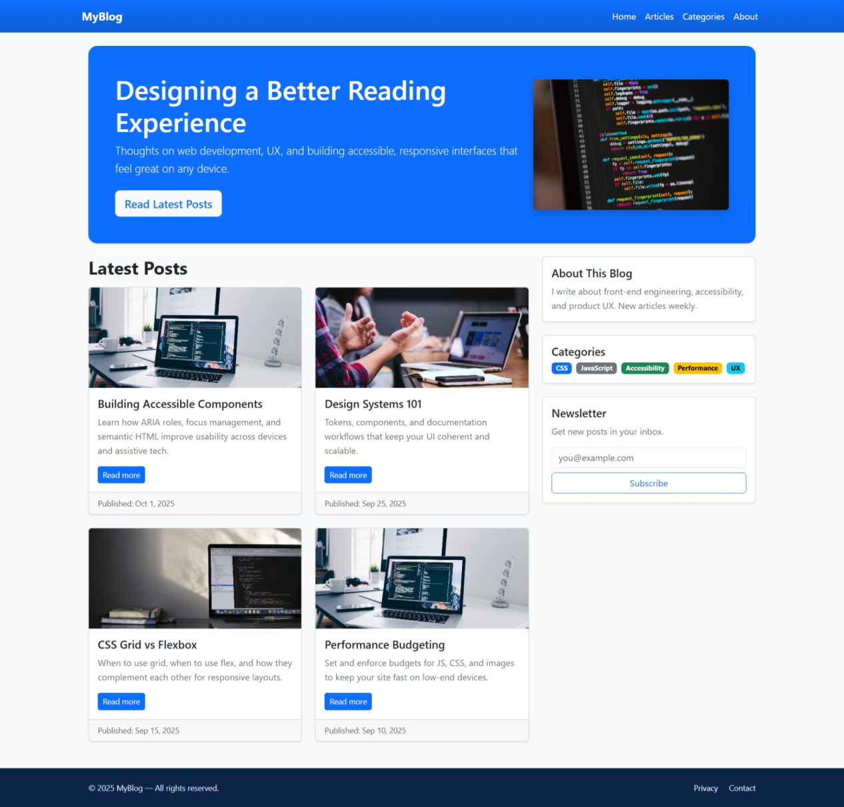

Experiment 7
Aim:
To develop a single-page application (SPA) using React.js that allows users to view, add, update, and delete notes.

Introduction:
React.js is a popular JavaScript library used for building user interfaces, especially single-page applications. A SPA loads a single HTML page and dynamically updates content without reloading the page. In this experiment, we create a Notes App that performs CRUD (Create, Read, Update, Delete) operations using React components and state management.

Requirements:
- Node.js and npm installed
- React.js (using Create React App)
- Code Editor (VS Code)

Algorithm / Steps:
- Install Node.js and set up React environment.
- Create a new React app using:
npx create-react-app notes-app
- Navigate to project folder:
cd notes-app
- Create components:
  - NoteForm (for adding/updating notes)
  - NoteList (for displaying notes)
  - NoteItem (for each note)
- Use React state (useState) to manage notes.
- Implement functions:
  - Add note
  - Update note
  - Delete note
- Render all components in App.js.
- Run the application using:
npm start

Program Code:
App.js
import React, { useState } from "react";
import "./App.css";
function App() {
const [notes, setNotes] = useState([]);
const [text, setText] = useState("");
const [editIndex, setEditIndex] = useState(null);
constaddNote = () => {
if (text.trim() === "") return;
if (editIndex !== null) {
constupdatedNotes = [...notes];
updatedNotes[editIndex] = text;
setNotes(updatedNotes);
setEditIndex(null);
} else {
setNotes([...notes, text]);
}
setText("");
};
constdeleteNote = (index) => {
constnewNotes = notes.filter((_, i) =>i !== index);
setNotes(newNotes);
};
consteditNote = (index) => {
setText(notes[index]);
setEditIndex(index);
};
return (
<div className="container">
<h1>Notes App</h1>
<input
type="text"
placeholder="Enter note..."
value={text}
onChange={(e) =>setText(e.target.value)}
/>
<button onClick={addNote}>
{editIndex !== null ? "Update" : "Add"}
</button>
<ul>
{notes.map((note, index) => (
<li key={index}>
{note}
<button onClick={() =>editNote(index)}>Edit</button>
<button onClick={() =>deleteNote(index)}>Delete</button>
</li>
))}
</ul>
</div>
);
}
export default App;

App.css
.container {
text-align: center;
margin-top: 50px;
font-family: Arial;
}
input {
padding: 10px;
width: 250px;
margin-right: 10px;
}
button {
padding: 8px 12px;
margin: 5px;
cursor: pointer;
}
ul {
list-style: none;
padding: 0;
}
li {
margin: 10px;
padding: 10px;
background: #f0f0f0;
display: inline-block;
}

Output:
A functional Notes Application where users can:
- Add new notes
- Edit existing notes
- Delete notes
- View all notes dynamically without page reload

Conclusion:
This experiment demonstrates how React.js can be used to build dynamic single-page applications. By using components and state management, CRUD operations were implemented efficiently, improving user experience without page refresh.

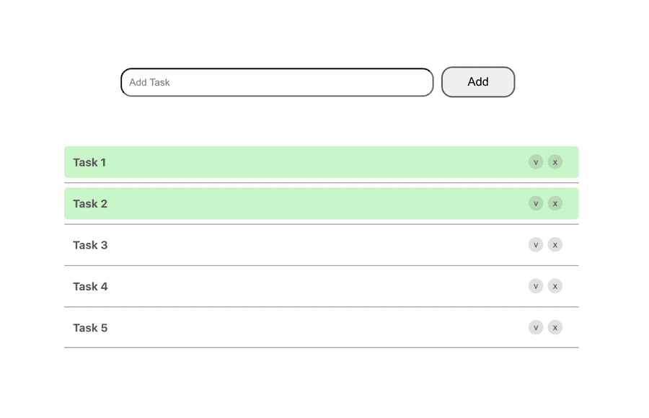

Experiment 8
Aim:
To design and implement a RESTful Web API using Node.js and Express.js that performs CRUD (Create, Read, Update, Delete) operations on a simple book collection.

Software Required:
- Operating System (Windows / Linux / macOS)
- Node.js (LTS version)
- Code Editor (VS Code / Sublime Text)
- Command Prompt / Terminal
- Postman (optional for testing API)

Theory:
1. RESTful API
REST (Representational State Transfer) is an architectural style used for designing network-based applications. A RESTful API uses HTTP methods to perform operations on resources.
Method | Operation | Example
GET | Read data | /books
POST | Create data | /books
PUT | Update data | /books/:id
DELETE | Delete data | /books/:id

2. CRUD Operations
CRUD stands for:
- Create → Add new data
- Read → Retrieve data
- Update → Modify data
- Delete → Remove data

3. Node.js and Express.js
- Node.js allows JavaScript to run on the server.
- Express.js is a framework used to build web APIs easily.
- It helps in routing, handling requests, and managing responses.

Algorithm / Procedure:
- Install Node.js.
- Create a project folder:
mkdir book-api
cd book-api
- Initialize project:
npminit -y
- Install Express:
npm install express
- Create index.js file.
- Write API routes for CRUD operations.
- Run server using:
node index.js
- Test API using browser or Postman.

Program (Source Code):
// index.js
const express = require('express');
const app = express();
app.use(express.json());
// In-memory data
let books = [
{ id: 1, title: "The Alchemist", author: "Paulo Coelho", year: 1988 },
{ id: 2, title: "The Hobbit", author: "J.R.R. Tolkien", year: 1937 }
];
// Home route
app.get('/', (req, res) => {
res.send("Welcome to Book API");
});
// GET all books
app.get('/books', (req, res) => {
res.json(books);
});
// GET book by ID
app.get('/books/:id', (req, res) => {
const id = parseInt(req.params.id);
const book = books.find(b => b.id === id);
if (!book) return res.status(404).json({ message: "Book not found" });
res.json(book);
});
// POST new book
app.post('/books', (req, res) => {
const { title, author, year } = req.body;
if (!title || !author || !year) {
return res.status(400).json({ message: "All fields required" });
}
constnewBook = {
id: books.length + 1,
title,
author,
year
};
books.push(newBook);
res.status(201).json(newBook);
});
// PUT update book
app.put('/books/:id', (req, res) => {
const id = parseInt(req.params.id);
const index = books.findIndex(b => b.id === id);
if (index === -1) return res.status(404).json({ message: "Book not found" });
books[index] = { ...books[index], ...req.body };
res.json(books[index]);
});
// DELETE book
app.delete('/books/:id', (req, res) => {
const id = parseInt(req.params.id);
const index = books.findIndex(b => b.id === id);
if (index === -1) return res.status(404).json({ message: "Book not found" });
const deleted = books.splice(index, 1);
res.json({ message: "Deleted", book: deleted[0] });
});
// Start server
app.listen(3000, () => {
console.log("Server running on http://localhost:3000");
});

Sample Input and Output:
1. GET All Books
Request:
GET /books
Response:
[
{ "id": 1, "title": "The Alchemist", "author": "Paulo Coelho", "year": 1988 },
{ "id": 2, "title": "The Hobbit", "author": "J.R.R. Tolkien", "year": 1937 }
]

2. POST New Book
Request:
{
"title": "Atomic Habits",
"author": "James Clear",
"year": 2018
}
Response:
{
"id": 3,
"title": "Atomic Habits",
"author": "James Clear",
"year": 2018
}

3. PUT Update Book
Request:
{
"title": "The Alchemist"
}
Response:
{
"id": 1,
"title": "The Alchemist",
"author": "Paulo Coelho",
"year": 1988
}

4. DELETE Book
Response:
{
"message": "Deleted",
"book": {
"id": 2,
"title": "The Hobbit",
"author": "J.R.R. Tolkien",
"year": 1937
}
}

